|  |  |
| --- | --- |
| **Team ID** | PNT2022TMID51066 |
| **Project Name** | AI-powered Nutrition Analyzer forFitness Enthusiasts |

**RUN THE APPLICATION**

**Running the app**

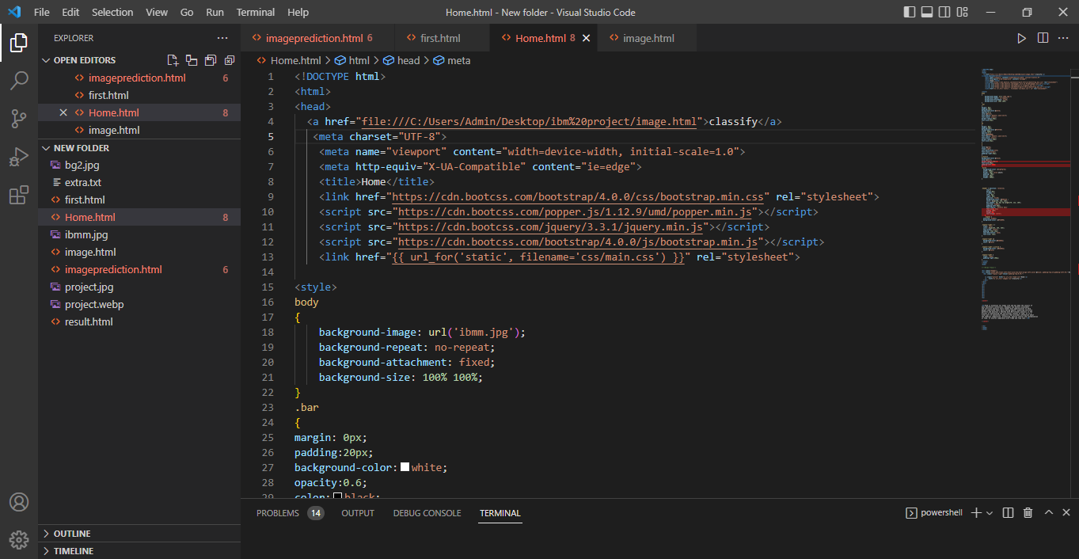

**HOME PAGE**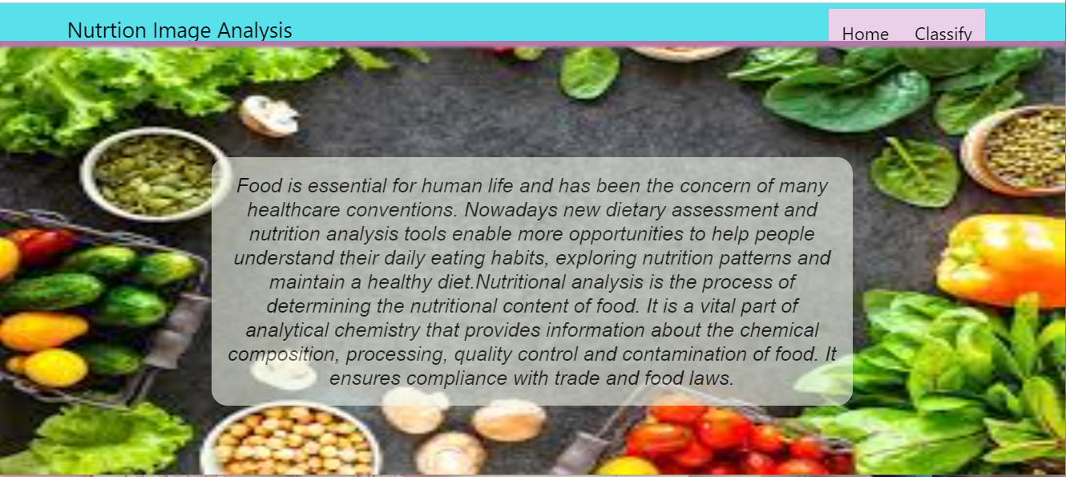

**IMAGE Page**

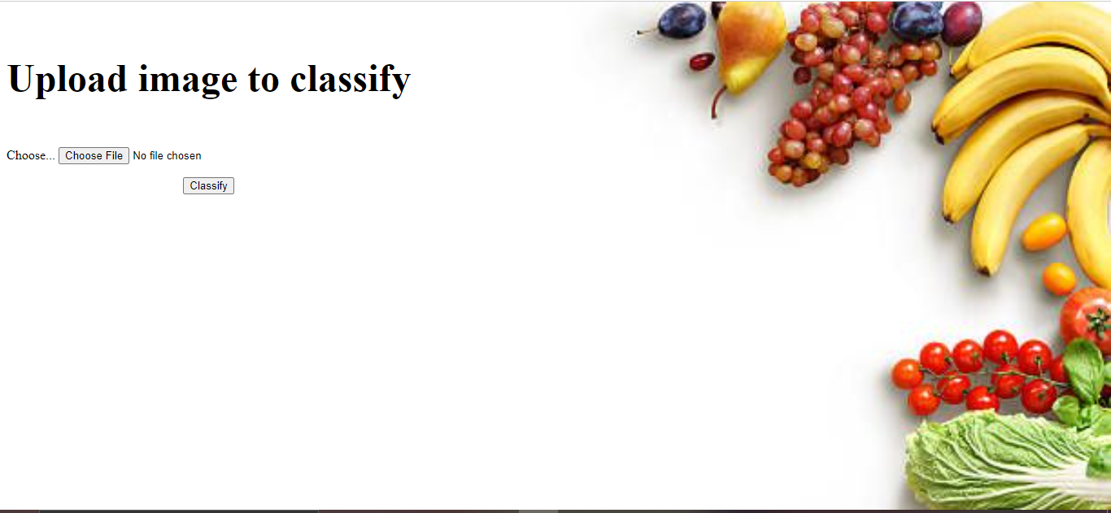

**RESULT PAGE**

